**Endnote 20: Difference with endnote X9**

The installation of EndNote for Erasmus MC will be upgraded to EndNote 20 in September 2021. Apart from the obvious visual changes there are some fundamental changes to the interface and the functionality of EndNote. They are described below.

**File conversion needed**

Each file that was created with a version of EndNote prior to EndNote X9.3 (any EndNote file that was created on Erasmus MC systems earlier) will have to be converted. You don't have to perform any action for it, only if you open an existing file a copy will be created that is called [your file name]-converted.enl (though you can choose to change the name in the process). The original file remains intact and can be used with EndNote X9 on other computers, but the converted file will be the file to use in EndNote 20. It is wise to remove or rename the original file as opening the file again will create a new file with the same same, which might overwrite the file that was created earlier.

**Opening EndNote**

Opening screen: choice open an existing library or create a new library

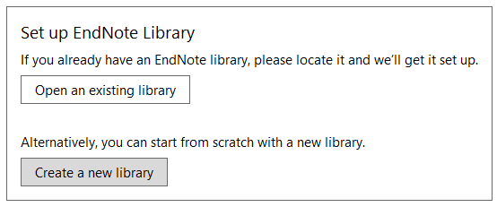

Just like in earlier versions when EndNote is opened for a consecutive time it will, just like the older versions, open the most recently used library.

**Tabs in the EndNote screen**

The preview screen cannot be shown at the bottom of the page as we recommend in X9. In stead there is a screen on the right side if the screen where the top part always shows the seleted reference in a standard summary format.

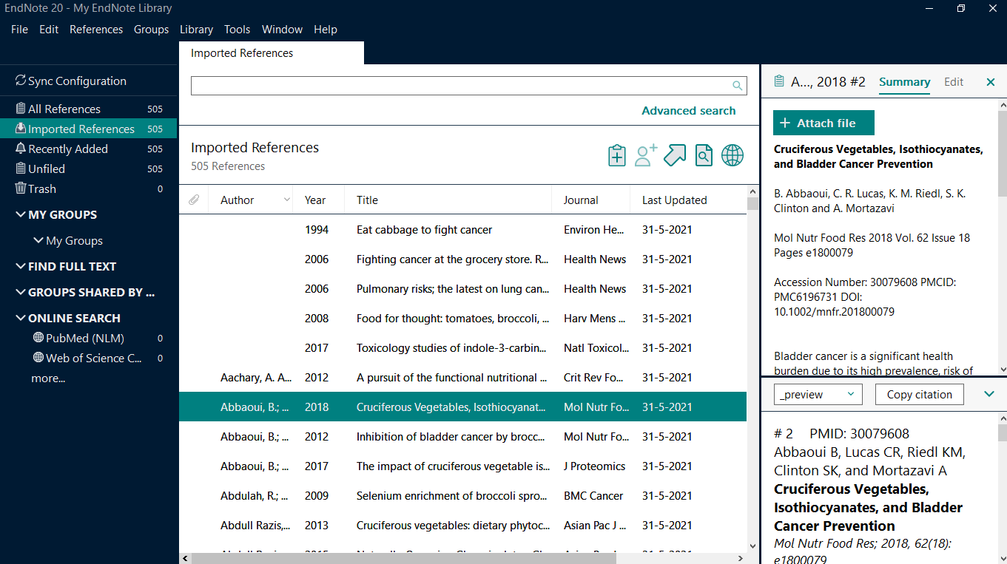

This can also show an Edit screen. Previously, in EndNote X9, Edits were done by right clicking the reference. This does not work anymore.

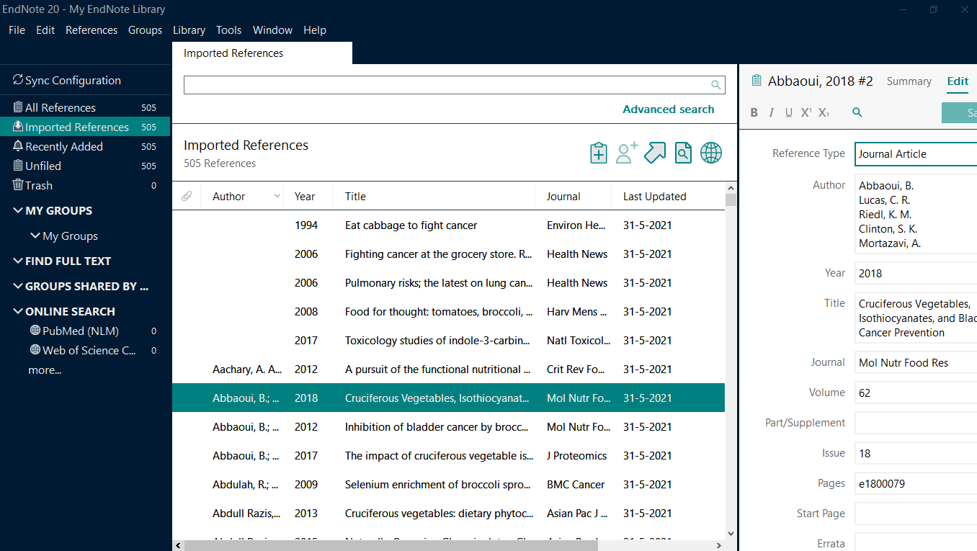

If you conduct a search the search terms are highlighted in both the table fields and in the side screen, but alas only in the edit mode. The highlighting in the table appears to have some flaws as not all words are highlighted. We have requested to show highlighting in the summary and preview tab as well.

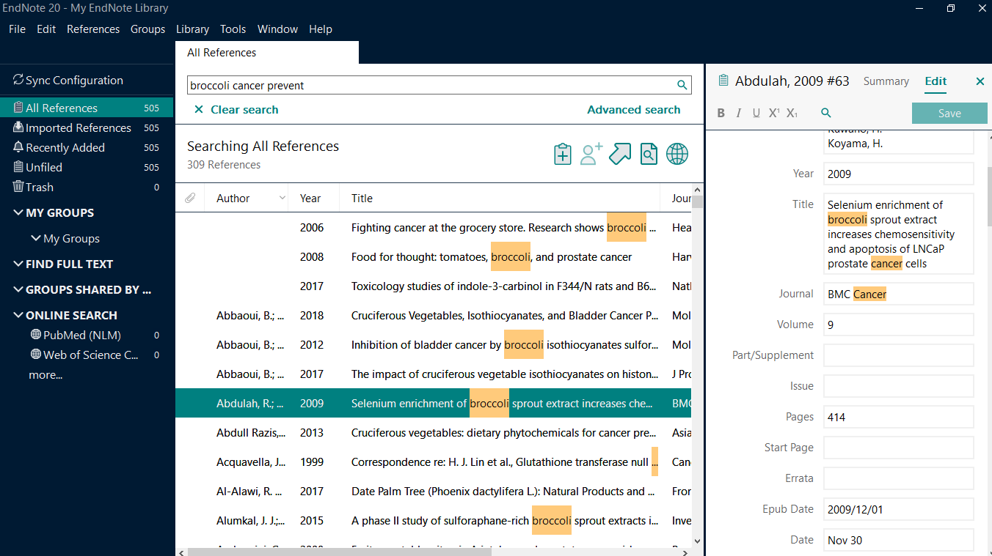

**Online Search via connection files**

There is no longer a difference between the three modes that were present until version X9 (local library mode, online search mode (temporary library) and integrated library mode. In the older versions we had recommended to use as much as possible the integrated library mode. The way EndNote 20 works closely resembles the online search mode.

If you perform a search using an online search connection all references are imported temporarily. You see tabs with numbers of references. You can select a page showing the first 25, 50, 75, or 100, or all references. You can choose to select all references from that page with the checkbox at the top left, or only a few refernces by checking only the checkboxes in front of the reference.

If you have selected the desired references you can add them to All References by clicking on the round button with the plus sign at the top right. Each time the button is clicked the selected references are added to the library. Therefore it is recommended not to click the button more than once.

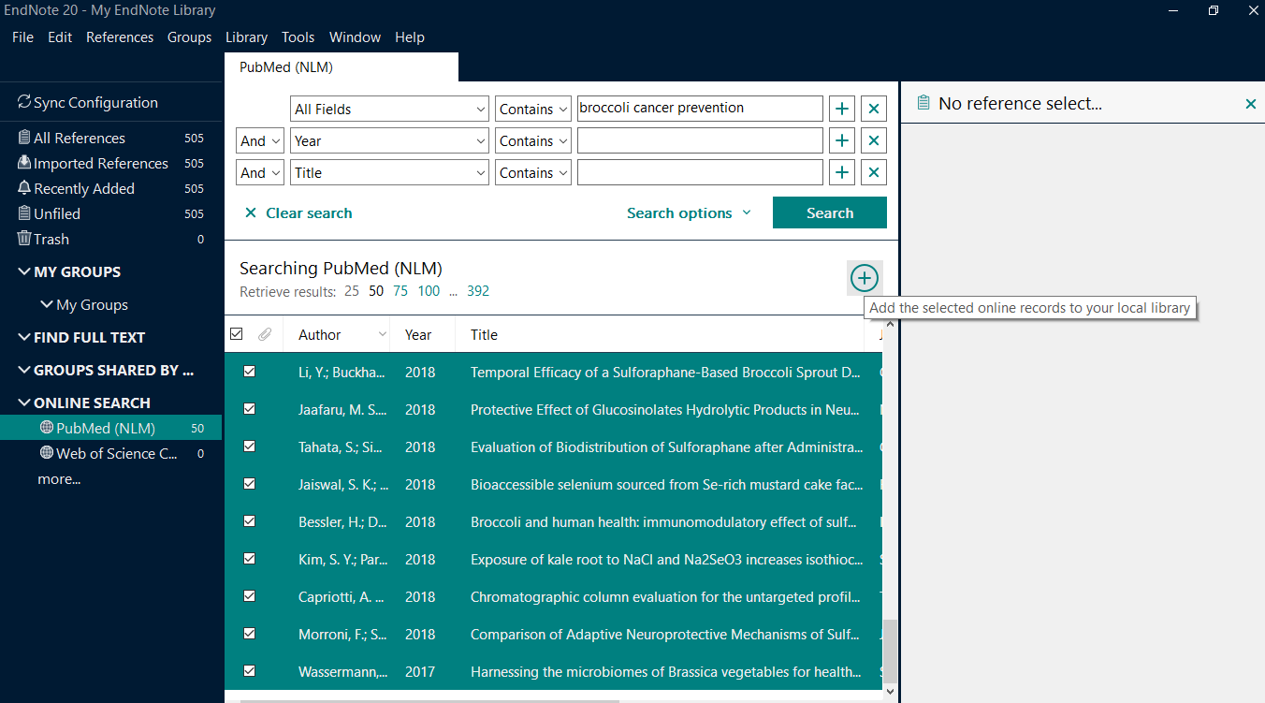

**Menu options have moved**

In older versions of EndNote the icons directly below the menu provided many short cuts to various tasks: import, export, find full text, as well as insert citations and other functions for Cite whil you write. These options can now only be accessed by the menu. The menu options have however changed drastically compared to earlier versions of EndNote.

There is a new Top menu item Library, in which you can find among others the options:

* Find Duplicates
* Terms Lists (for full and abbreviated Journal Titles)
* Change/ Move/ Copy Fields

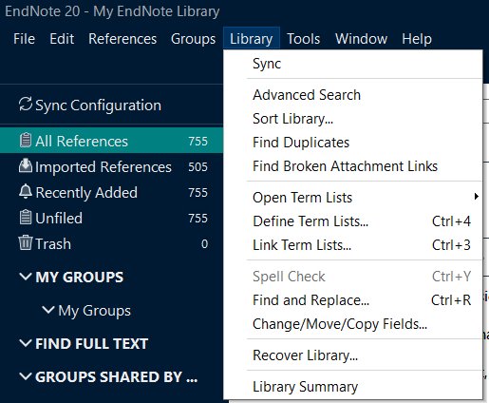

Selecting and editing Output Styles, Import Filters and Connection FIles has moved to the Tools menu.

